1.)Monitoring:-setup a Prometheus on virtualbox with alert manager and also install and setup Grafana

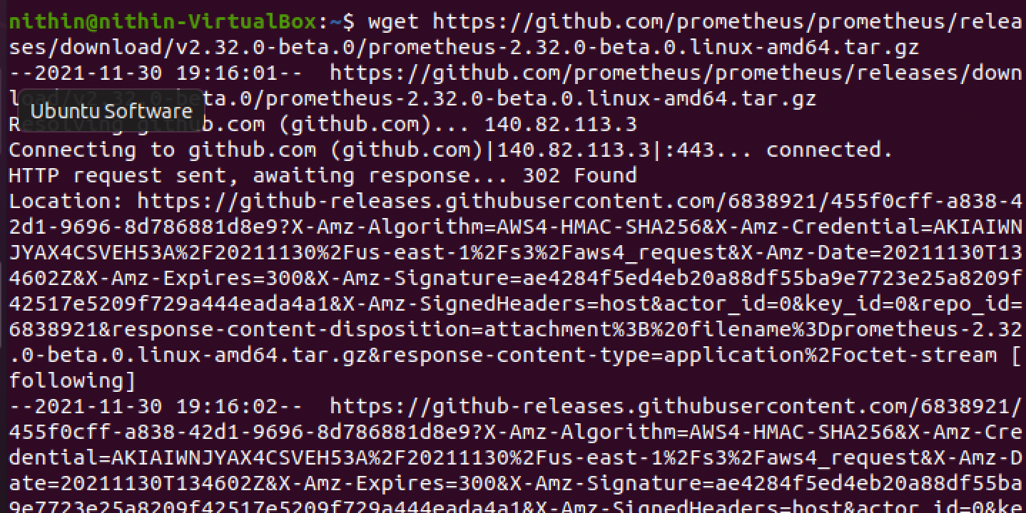

Installation of promtheus

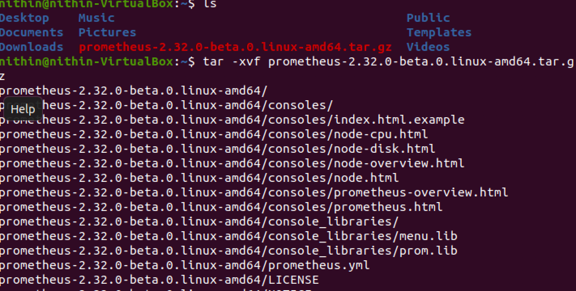

Unzip the file using tar then it unzip all the Prometheus related files

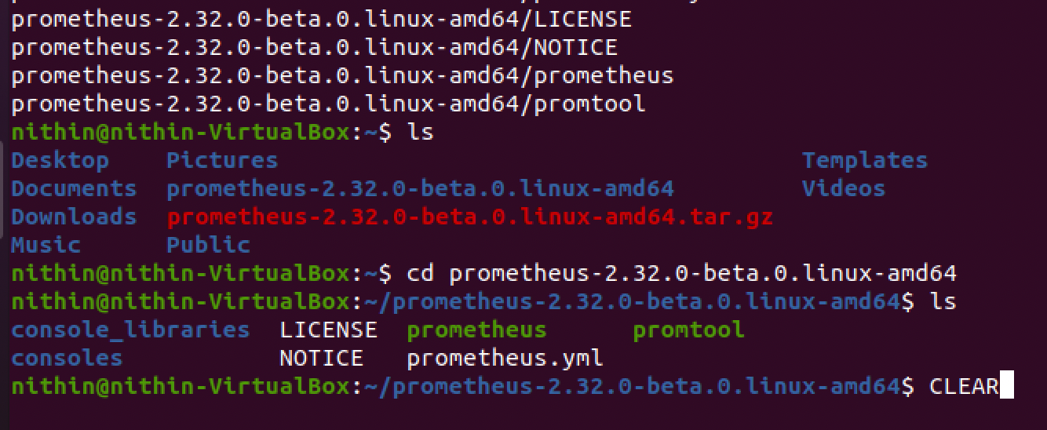

We have to locate to that particular Prometheus folder

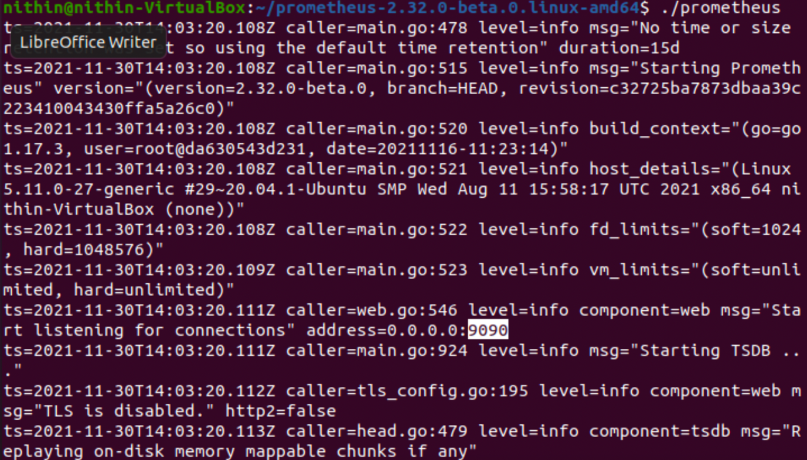

And run the Prometheus for a time being to check it is settingup successfully or not

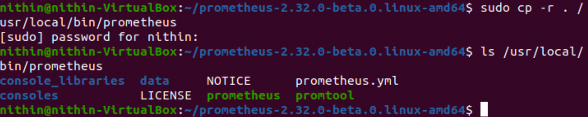

Copy to usr/local/bin/Prometheus and give ls to see successfully copied or not

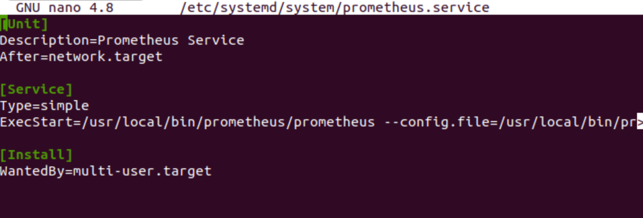

The file under the bin has Prometheus service with a service of type simple and execstart of Prometheus and Prometheus.yml

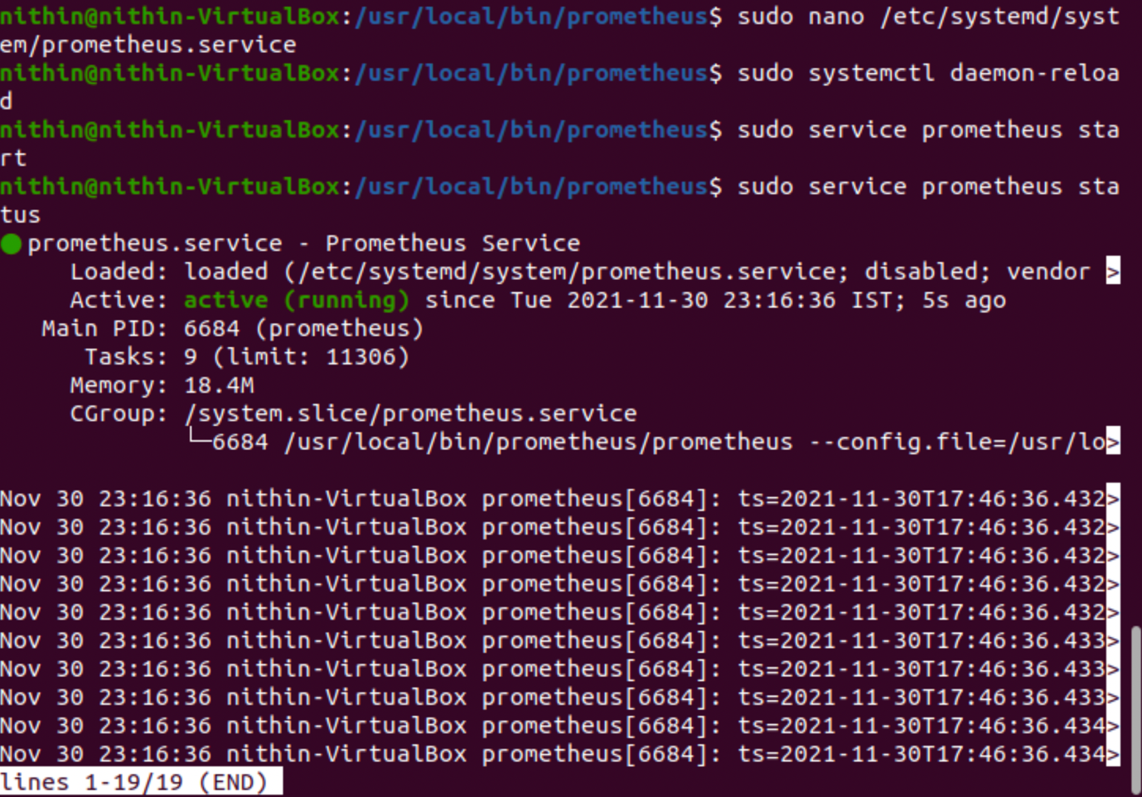

After that we can run the Prometheus with the file attached and start the service and get to know via status wheather it is running successfully or not

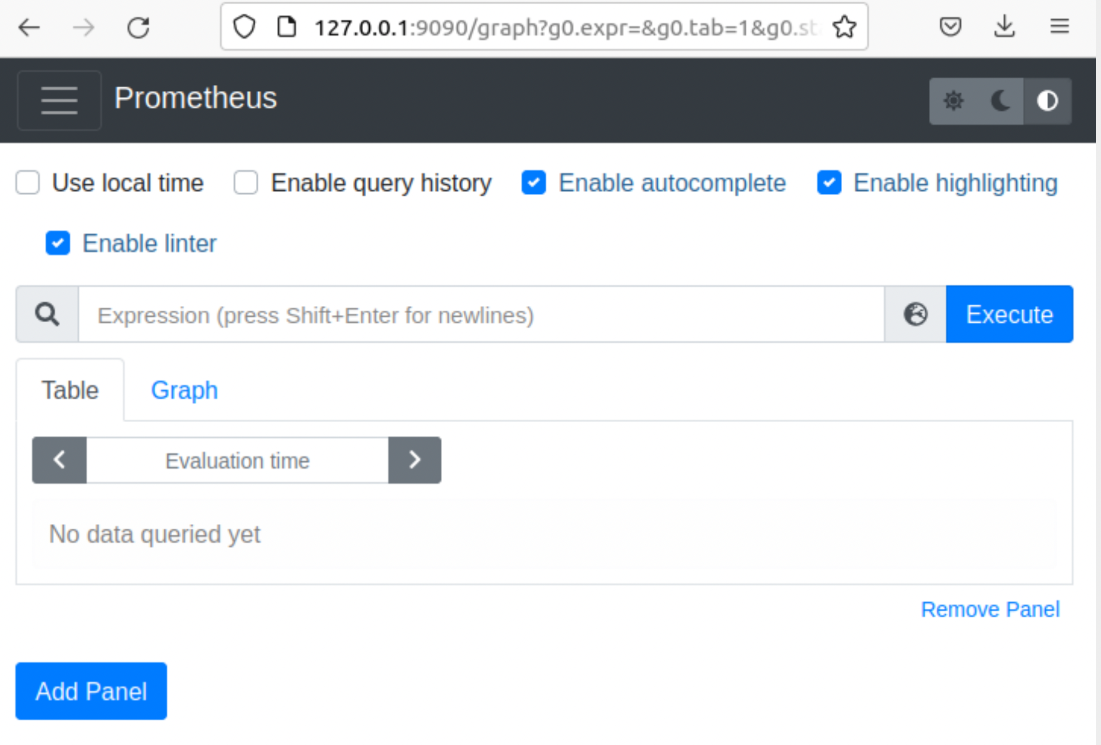

It hosted on localhost:9090 port

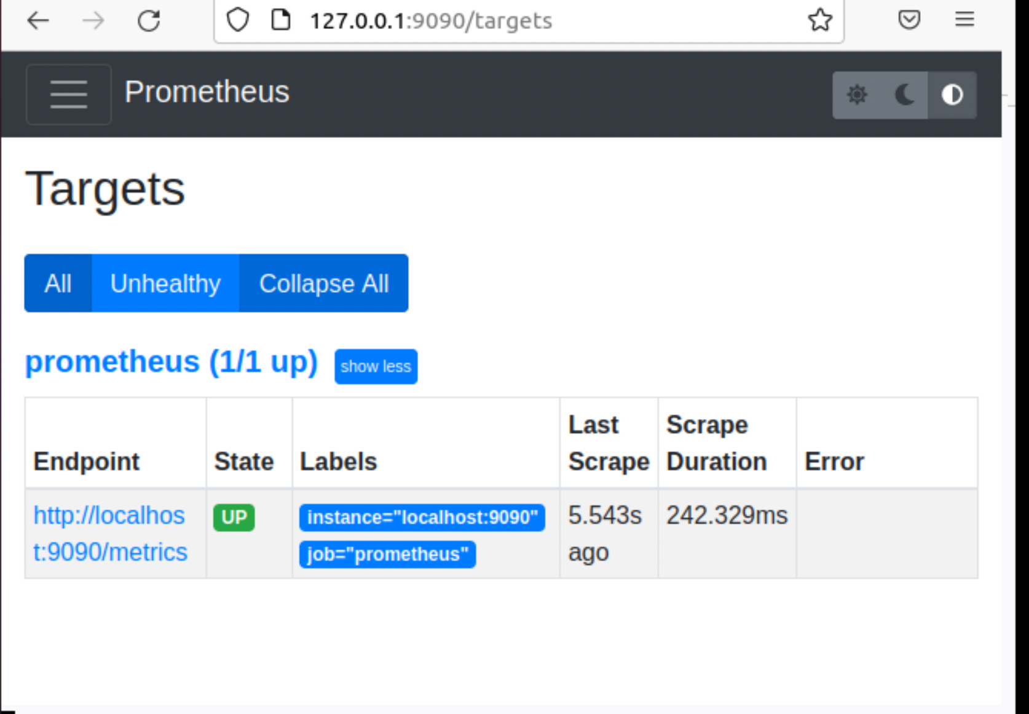

It is used to check the metrics for itself by default

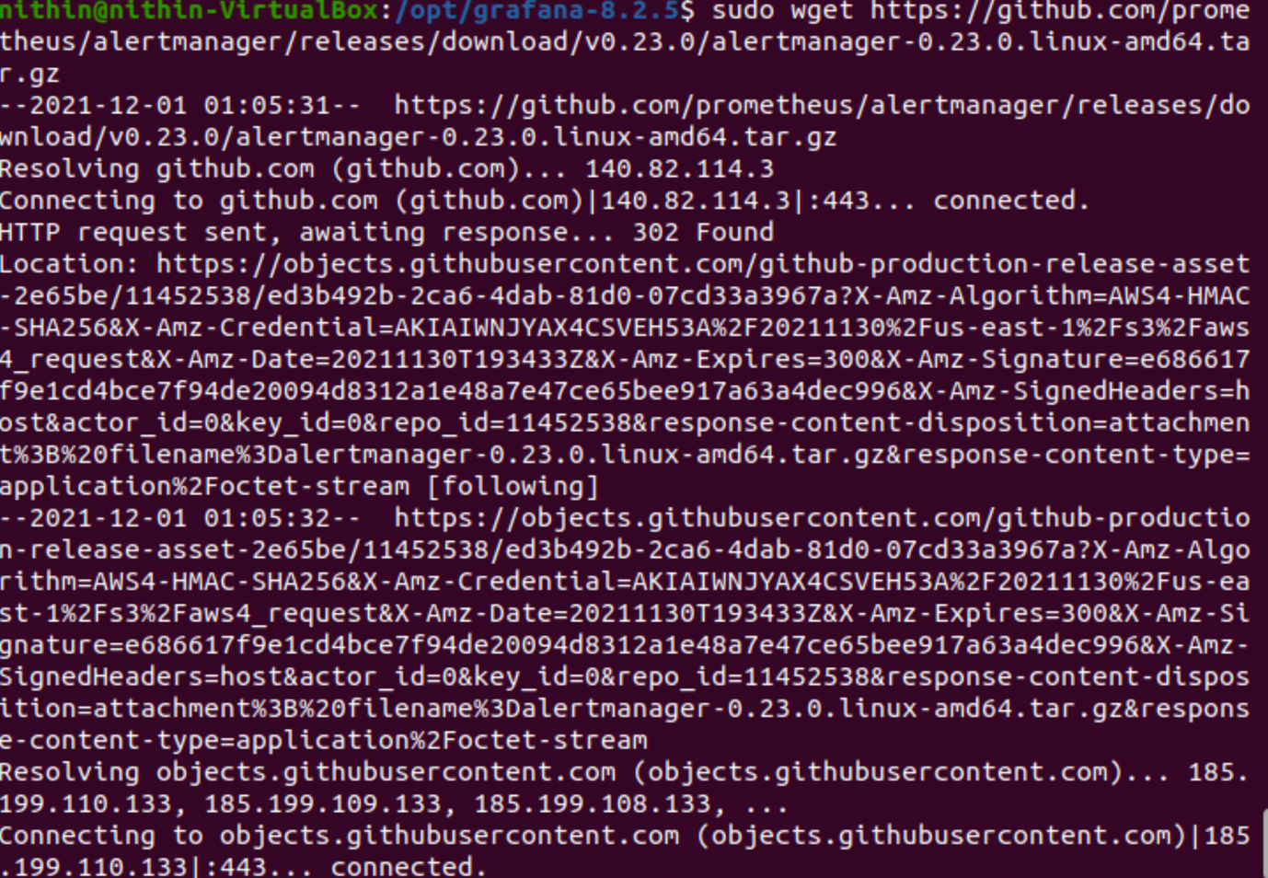

Installation of alertmanager

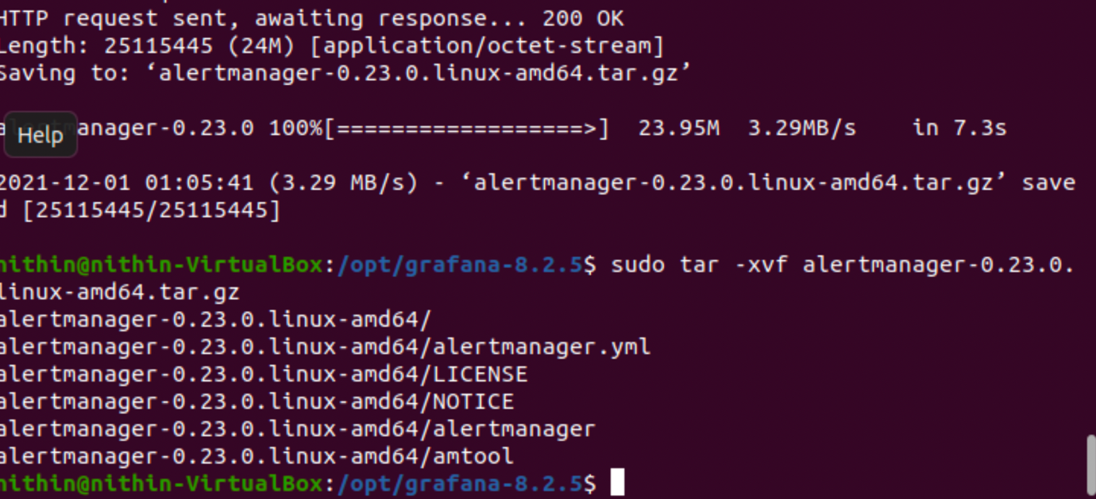

Unzip the file using tar

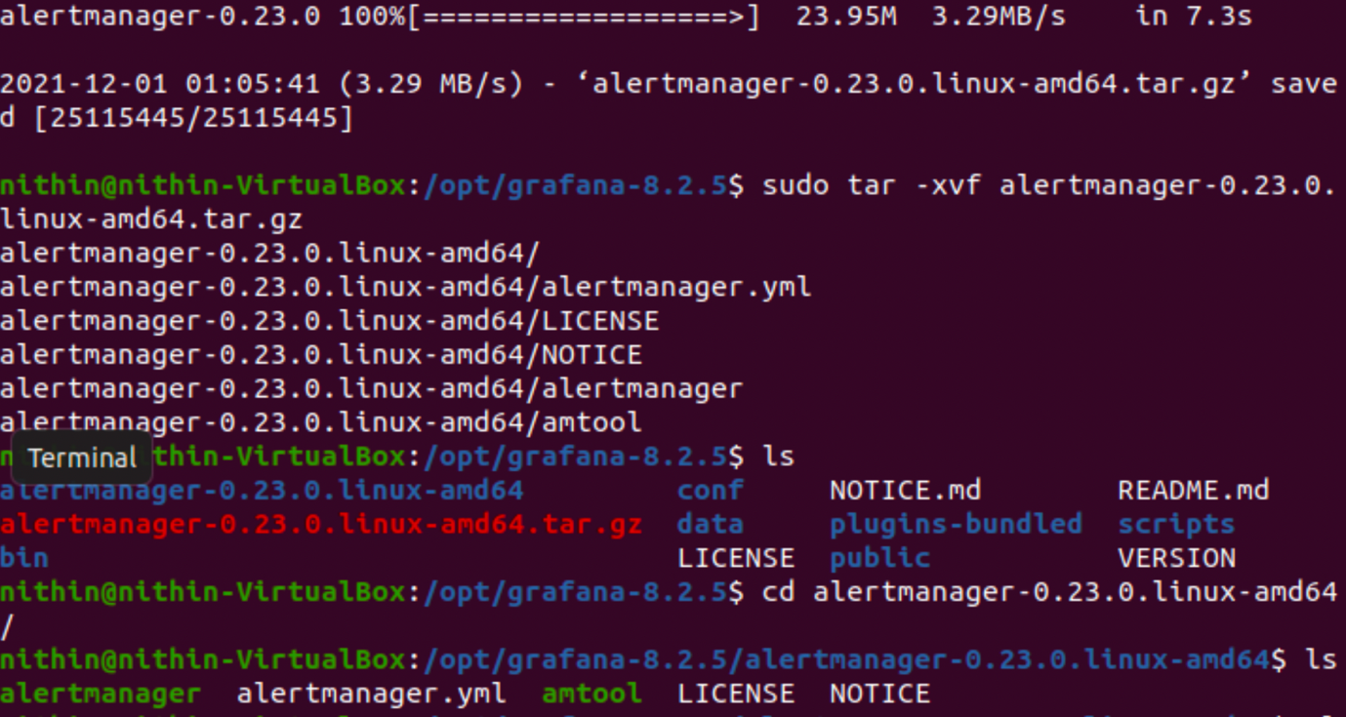

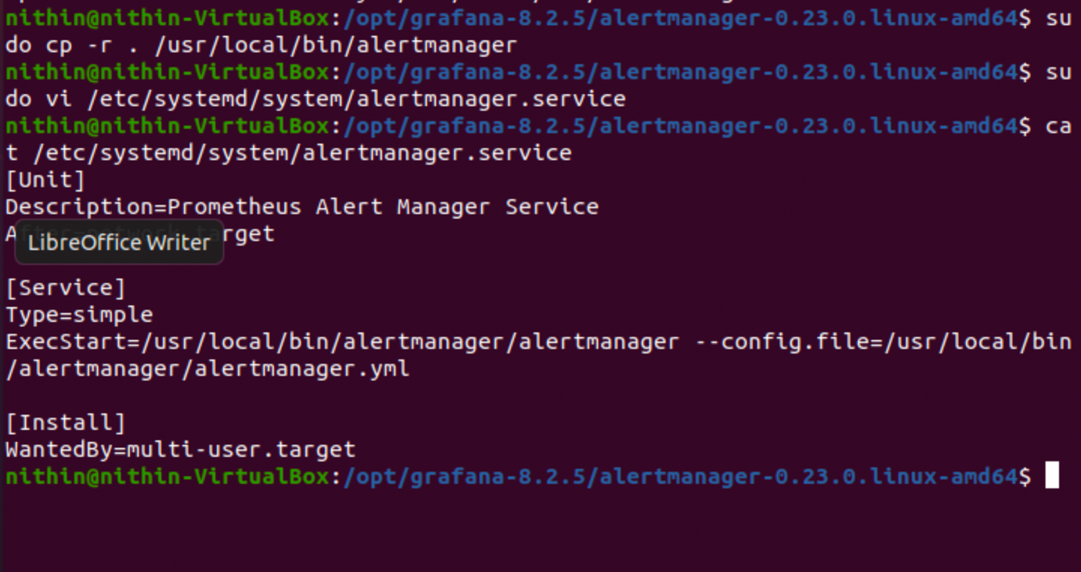

Code says to start exec and configure the .yaml file

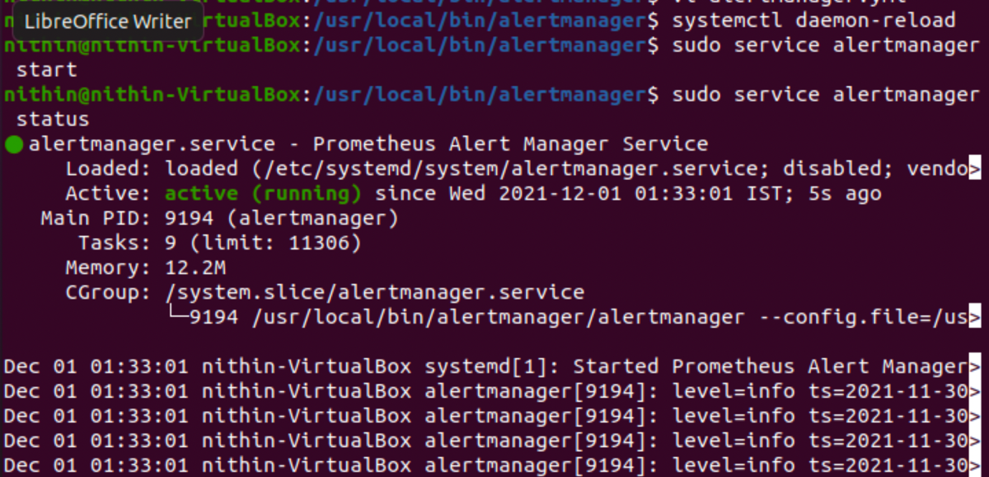

Start and status shows the setup of alertmanager

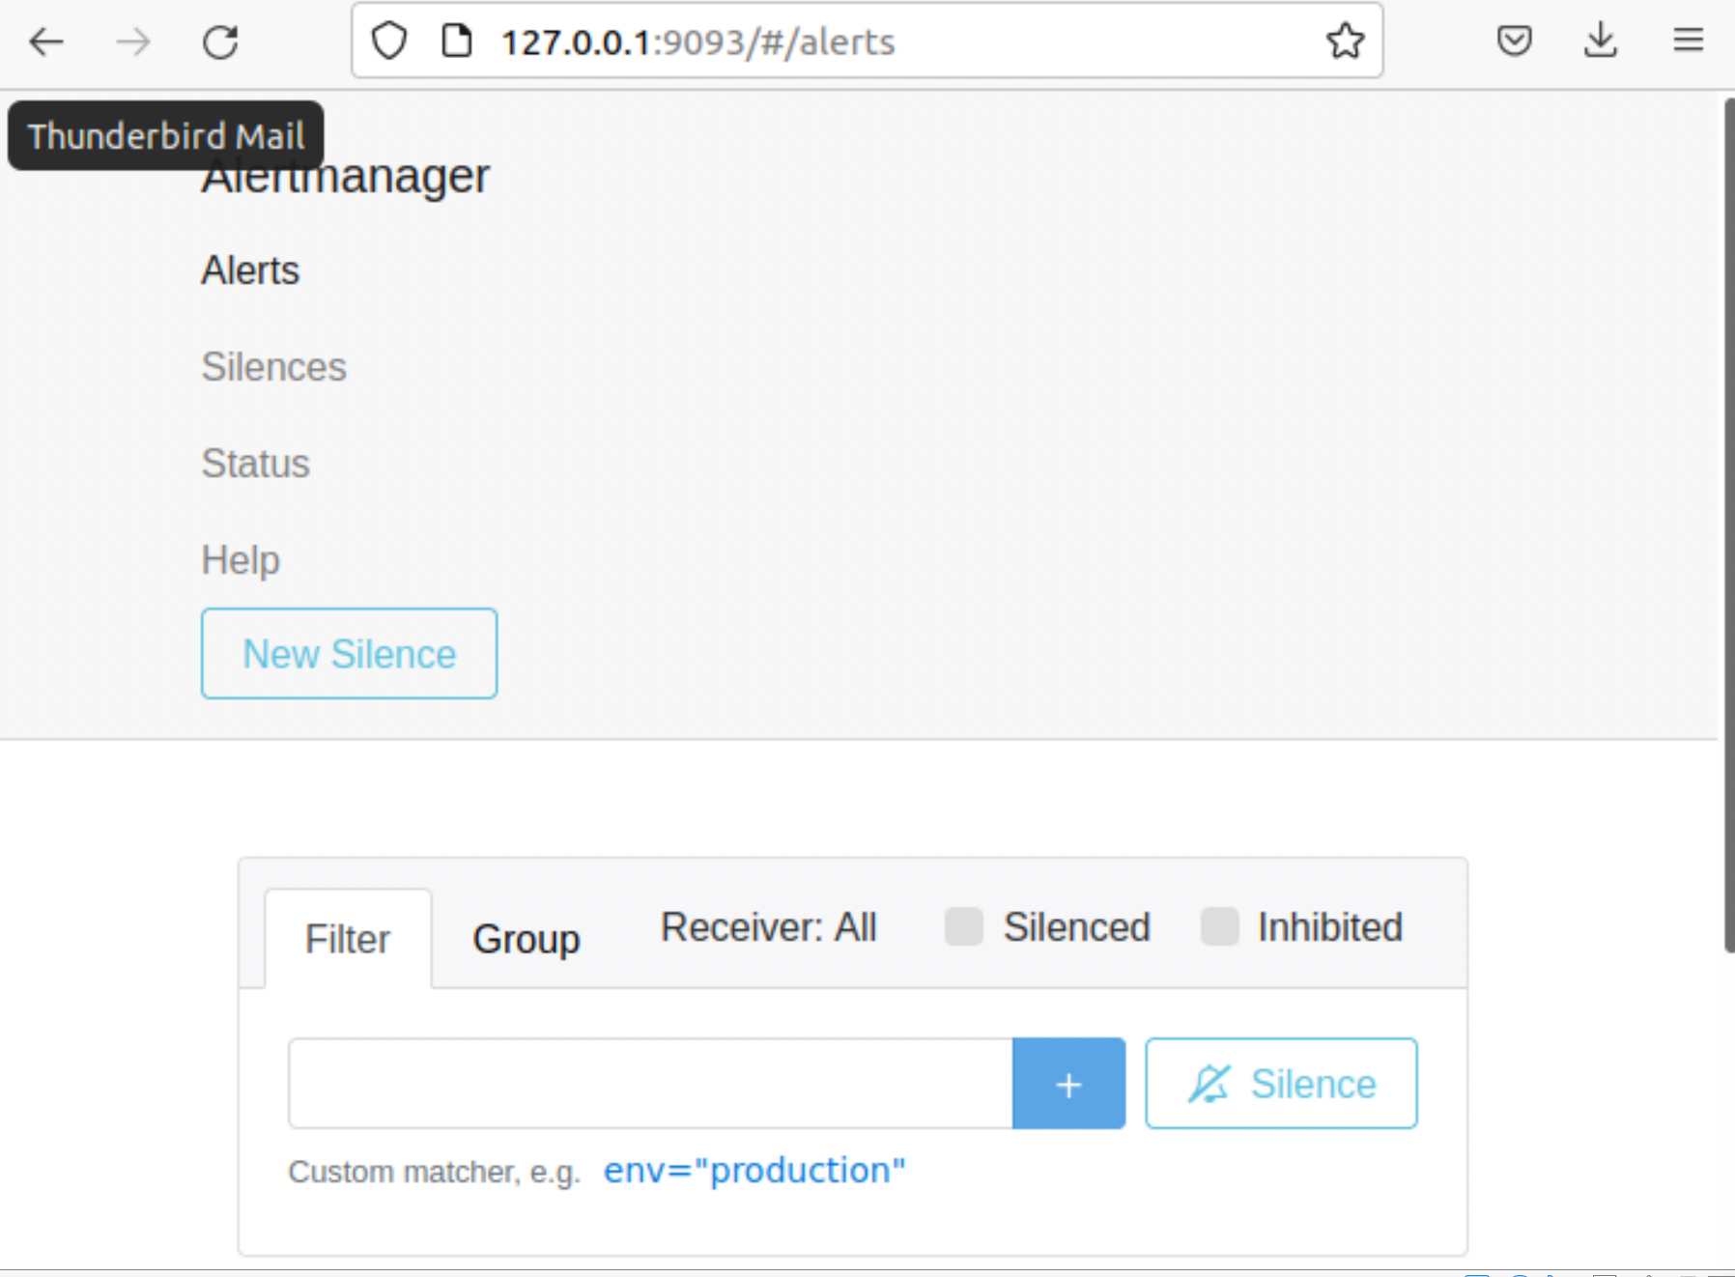

Hosted on localhost:9093

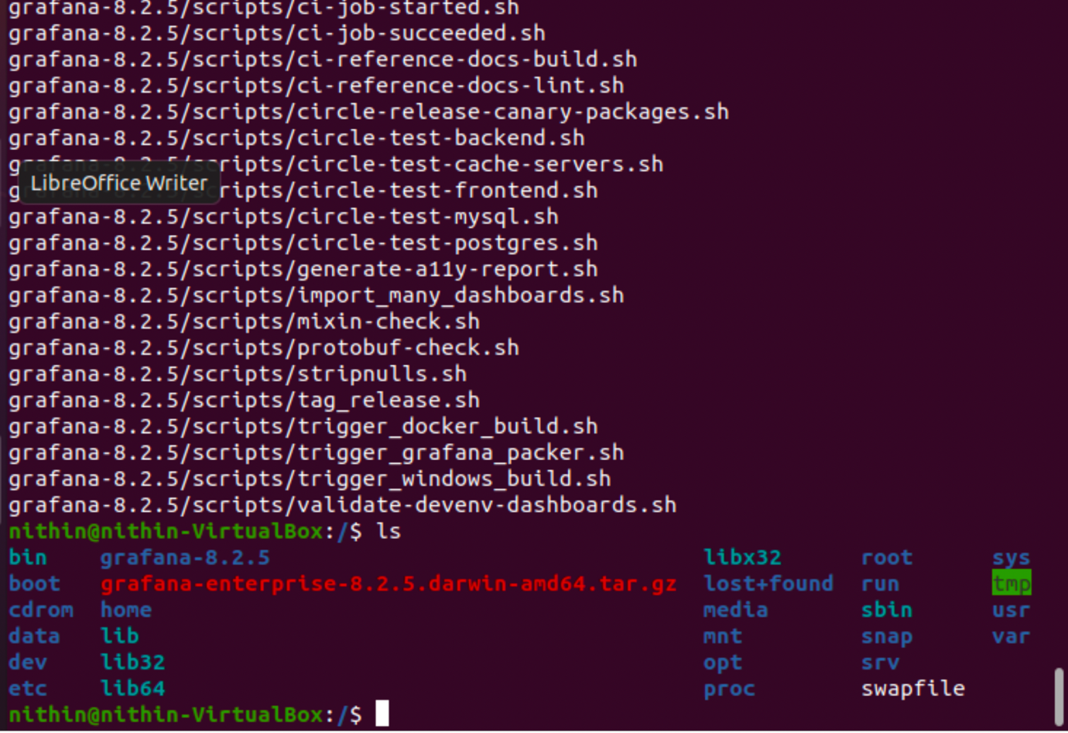

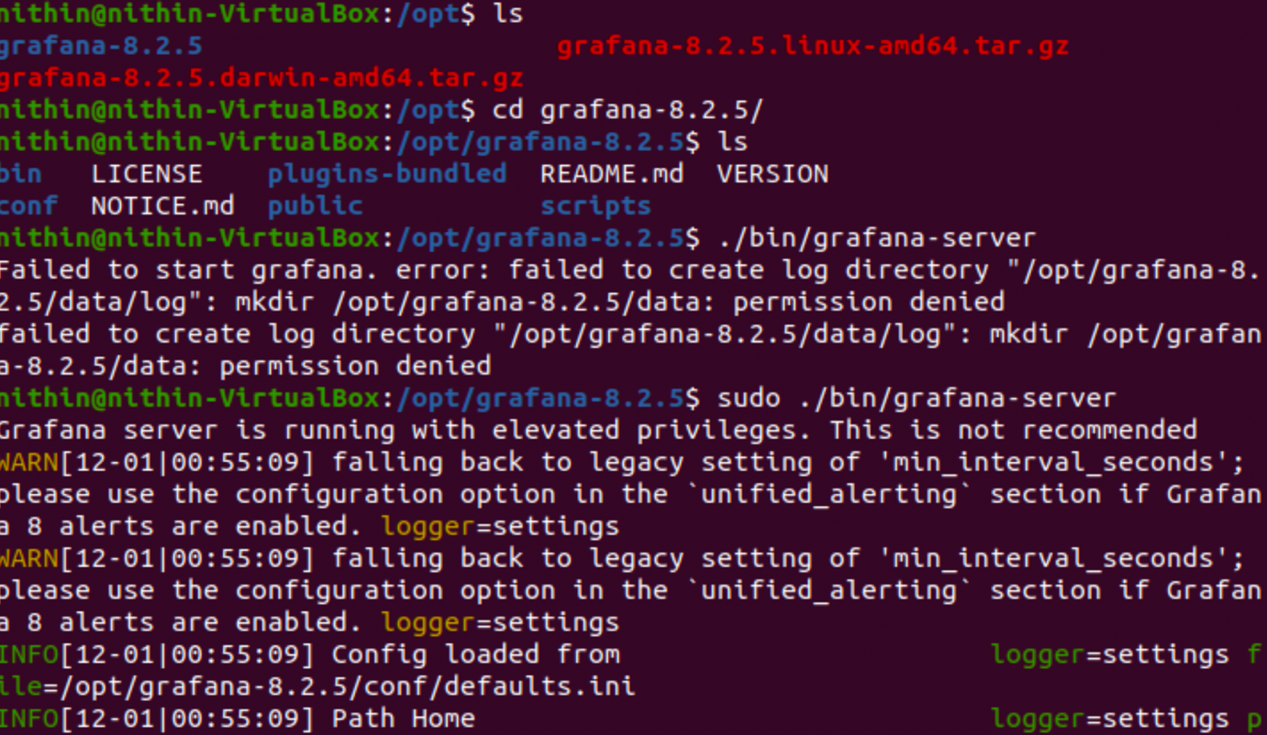

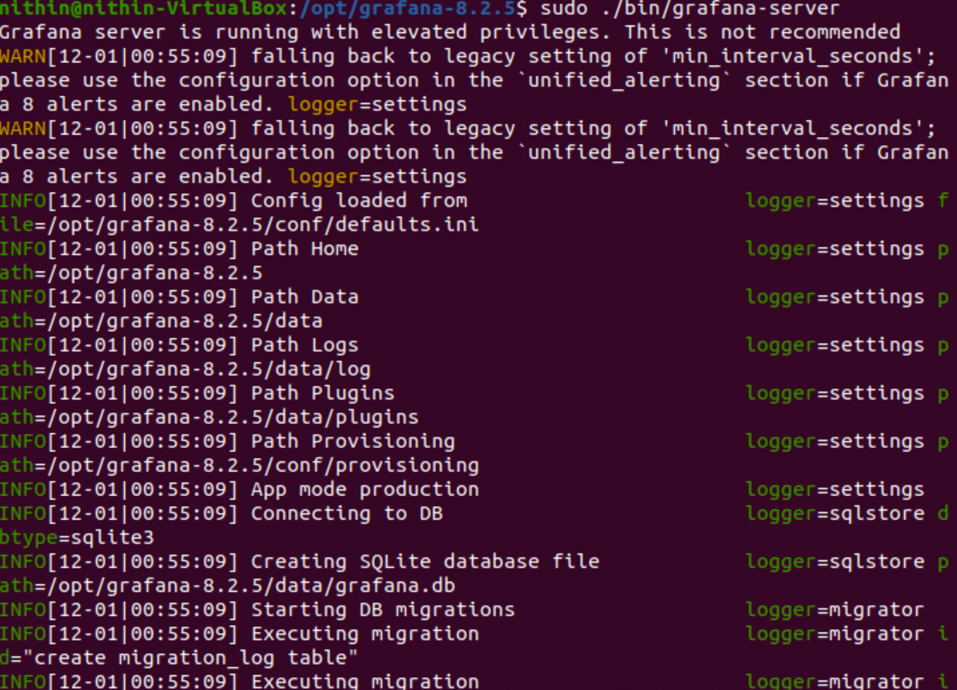

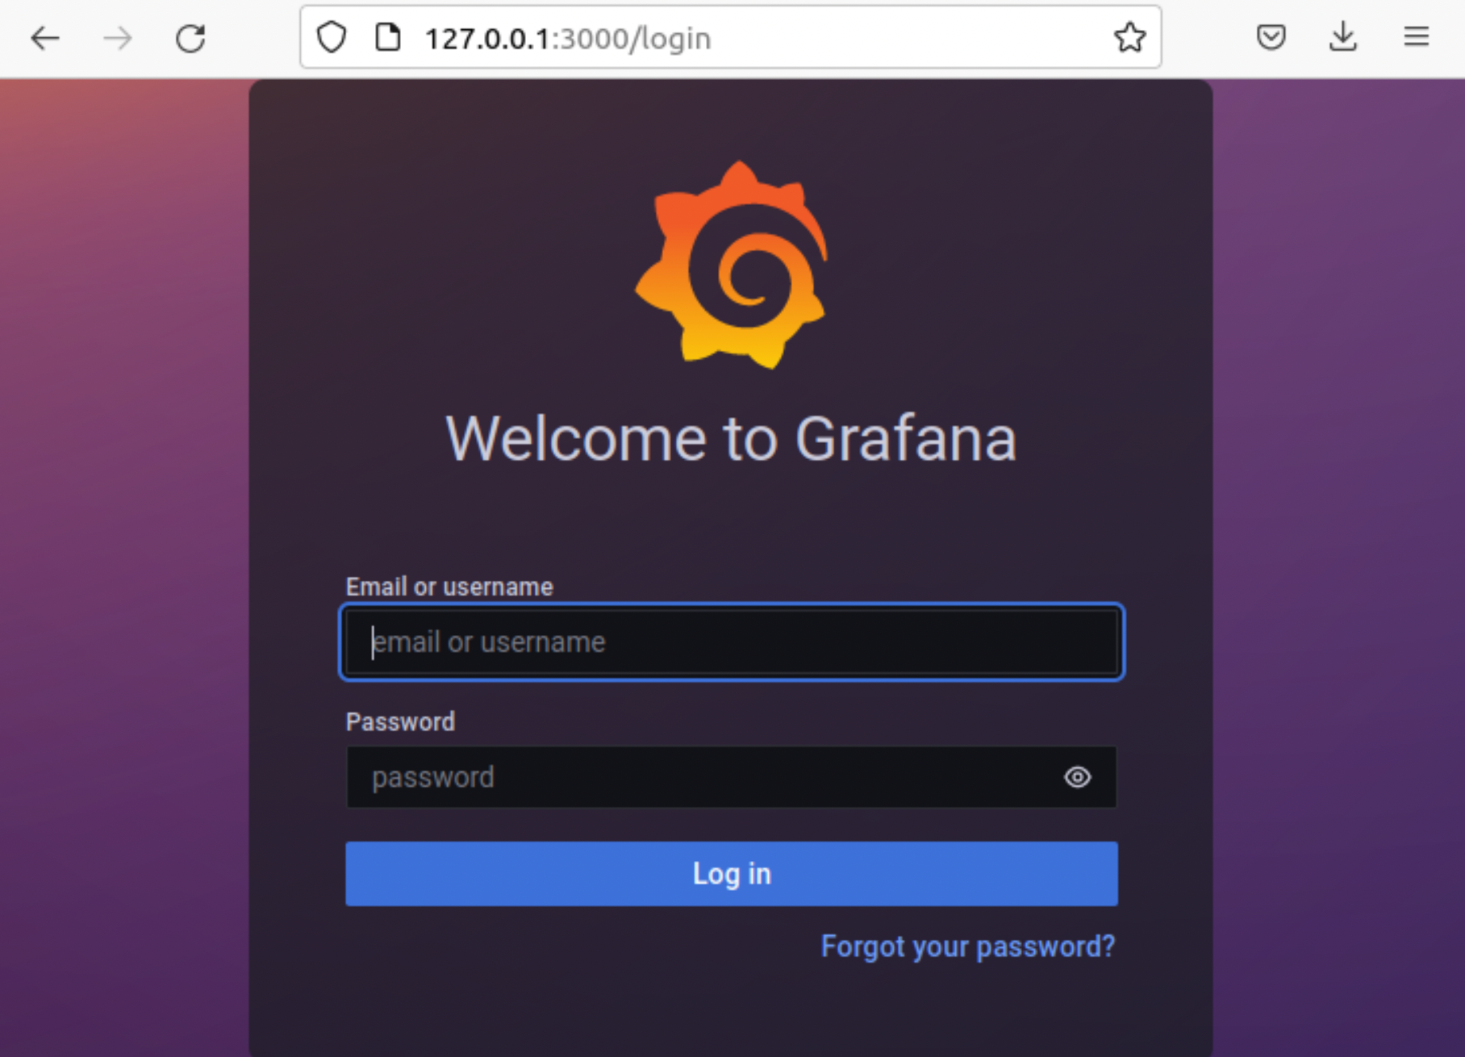

2.Logging:-

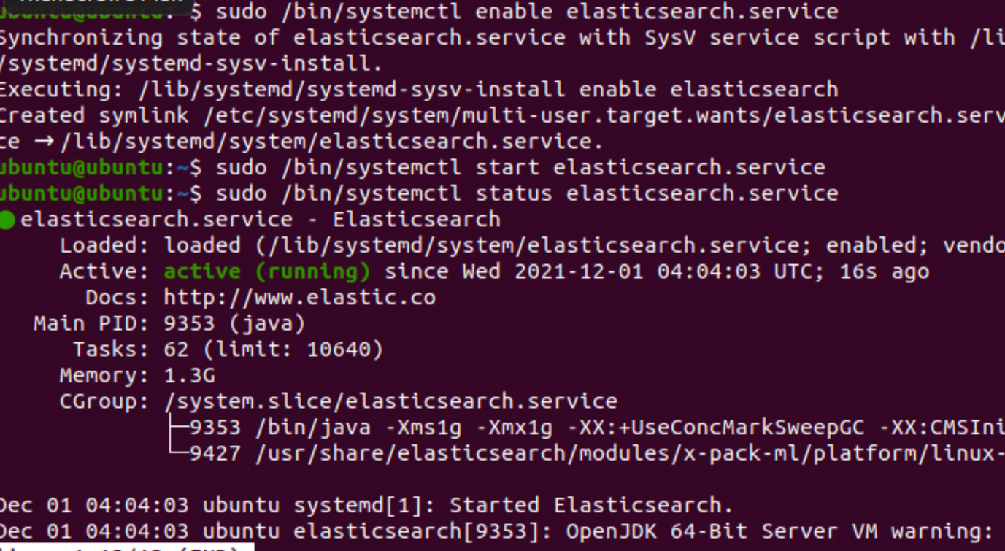

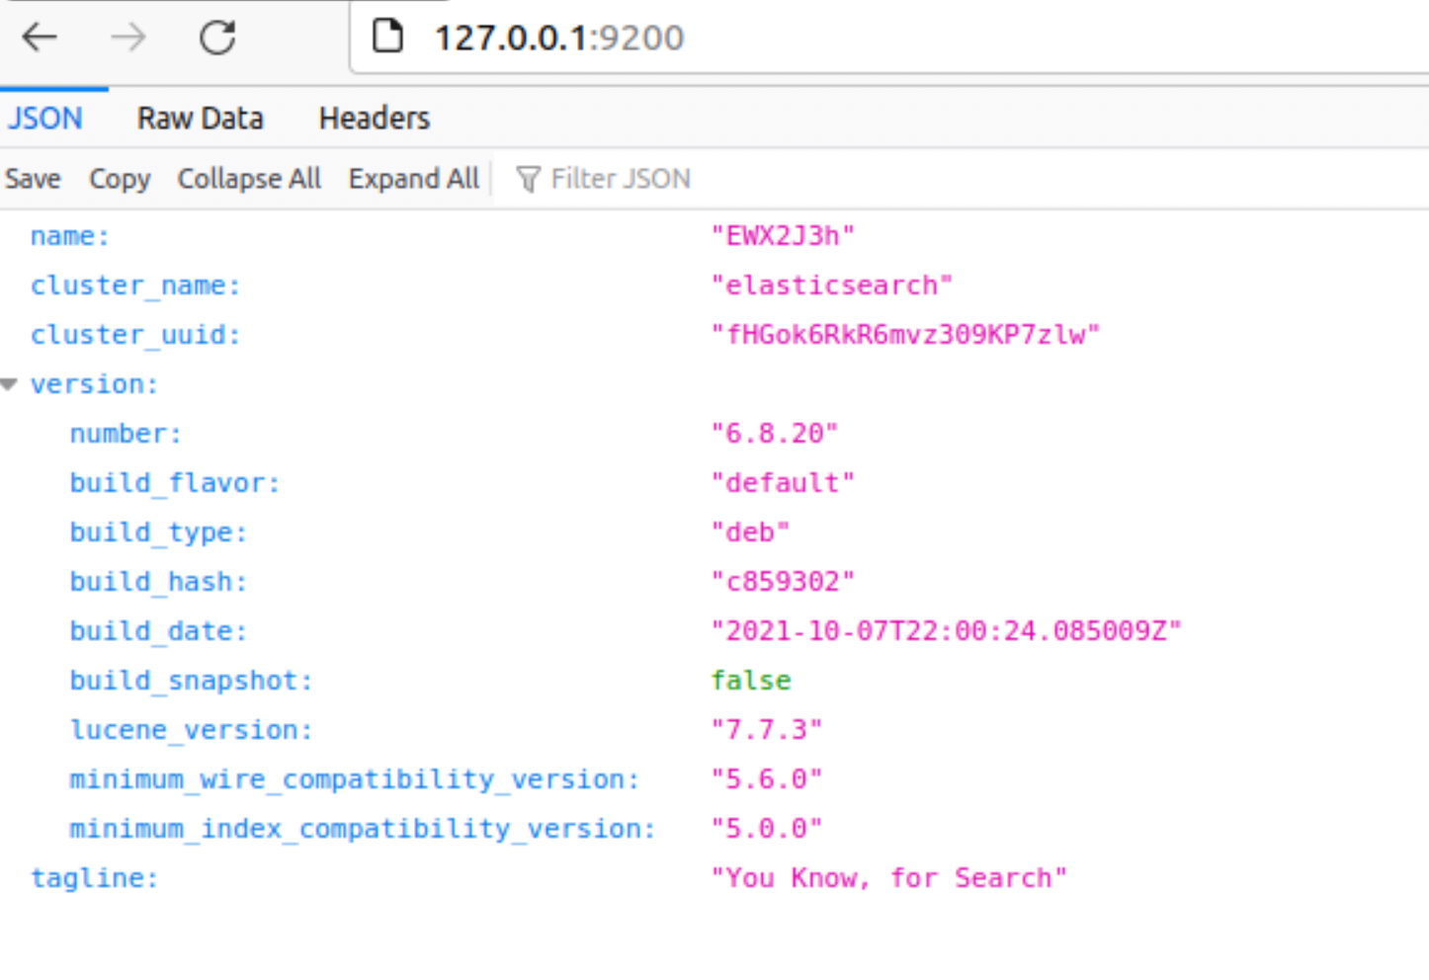

3.)APM:- Deploy Elastic beanstalk · Download sample data here

· Navigate to Elastic beanstalk and create application

· Select java 8 as version

· Upload the downloaded zip file

· Create application

· Access the application using eb endpoint

View traces on Xray

Navigate to X - ray and click on service map

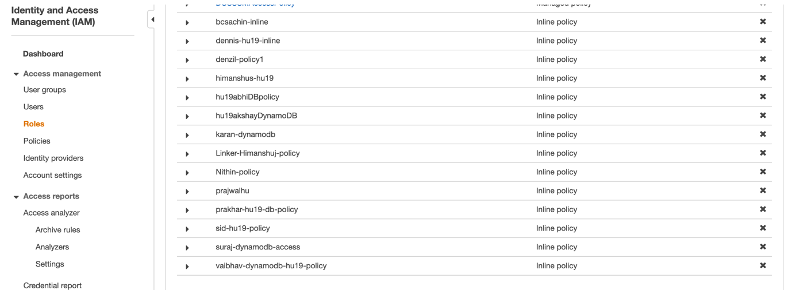

Policy is created with my name itself in Iam

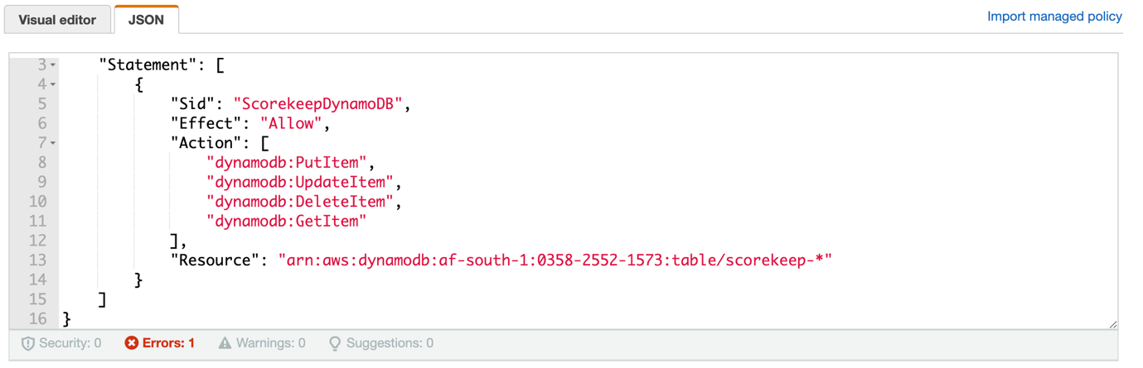

A policy is attached to it and specify the location and account id of user

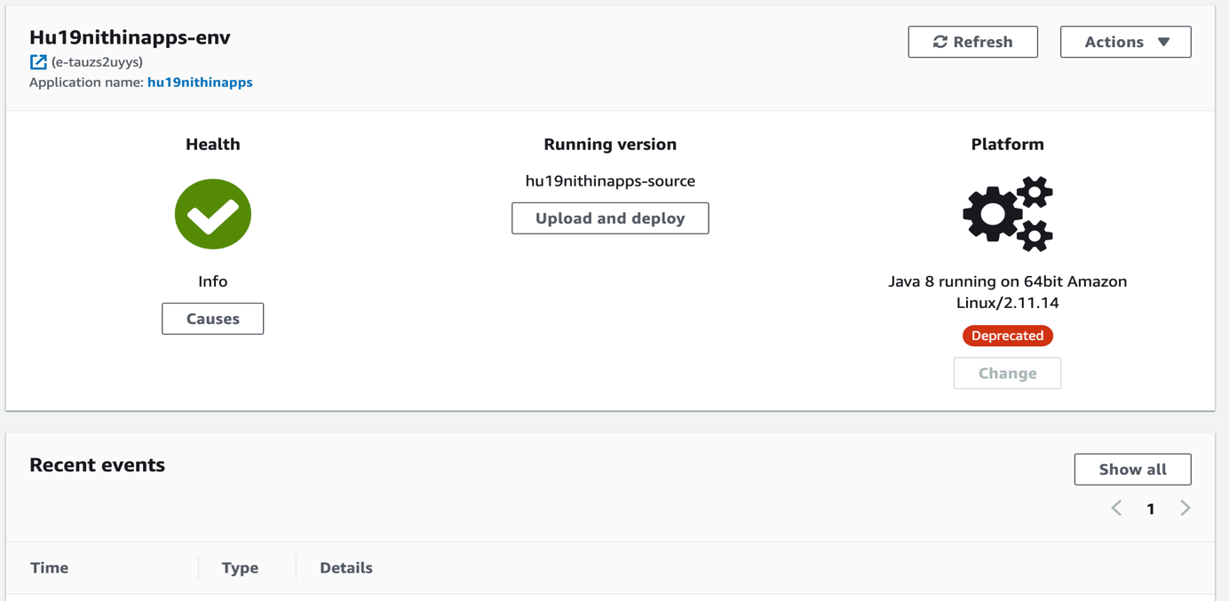

Health check is passed and got info

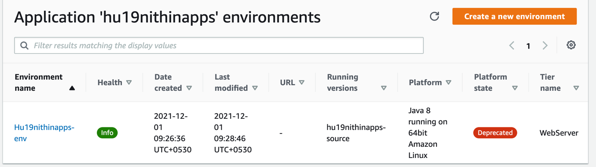

Before creating application and deploying it should be created inside environment

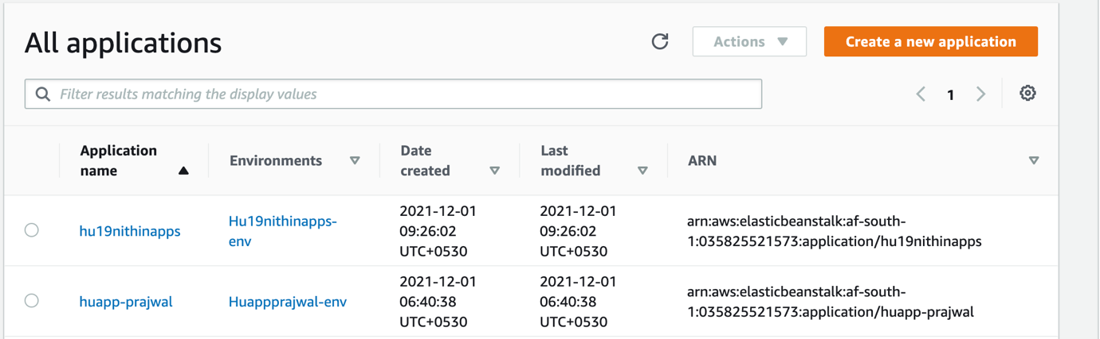

And application name as above